Individual Landowner Forestry Environmental Plan.

1. Document purpose:

To help you:

- Plan what forestry you would like to incorporate into your land and assist you on how to make this happen;
- Help you confirm what legislation, rules, plans etc. apply to your land and what funding you may be eligible for;
- Manage any existing forestry you have, including harvesting or changing one type of forestry to another (exotic to native for e.g.); and
- Identify the ideal outcome for your forest and land, then help to realise your vision.

2. Vision, Outcome, and Objectives:

Clearly state what your ideal final vision is and the overall outcome and objectives you as the landowner really would like to achieve with forestry on your property.

In developing your vision, outcome and objectives, think about what the site(s) lend themselves to (e.g., level of regeneration potential/seed sources, soil conditions, climatic conditions, weed issues). What else has worked well in your landscape or in similar areas of New Zealand? What could you do differently? Also, think about which species are present, their age, history, condition, characteristic plant or animal species (e.g., blackberry infestations, māhoe regeneration, presence of a korimako/bellbird population). What interactions are occurring within the forest? Develop some clear ideas about what other benefits you would like, such as improved water quality, an income stream, diversity and ecosystem function, sustainable harvesting through continuous cover forestry of native trees for generations to come?

We can provide you with some guidance but ultimately the outcome and objectives should come from you. At a high level the outcome should come from one of the five following scenarios:

- Harvest the plantation forest on your land and revert all the land to native forest – either through natural or assisted reversion.
- Do not harvest the plantation forestry on your land (due to financial, safety and/or environmental constraints) and allow and/or assist the land to revert back to native forest.
- Harvest the plantation forest on your land and re-plant with another rotation of plantation forest – either same species or a mixed stand.
- Establish either exotic or native forest on land that is currently unproductive, erosion prone or identified by you as a desirable place to establish a forest.
- A combination of the above.

Vision:

Overall Outcome:

Objectives:

3. Action Plan to Achieve Your Outcome and Objectives:

This is where the steps that need to be taken to meet the objectives are listed, e.g. if you want to transition to natives, you will need to order trees by a certain time, and phase your planting. We will aim to incorporate the actions from this plan into your forest operational plan, both the financial aspects and the actual operations.

The action plan will include:

- Specific individual actions required to achieve each objective, listed and tracked using a traffic light system to easily monitor progress;
- Include the proposed forestry treatments that you can also map out in section 4;
- The required resources (materials, labour and cost);

If the NES-PF applies to your scenario you may need to contact a forestry consultant to complete the following:
- Environmental plan;
- Harvesting plan;
- Erosion and sediment control plan;
- Planting plan;
- Maintenance and monitoring plan.

Actions:
List all the individual actions you know will need to be completed to achieve the objectives and relate them directly to the objectives above, for example Action 1.1 will be the first action required to help achieve Objective 1. We can go through the list with you if you like to see if there is anything else that may need to be listed.

Example for scenarios 1 and 3:

Objective 1 – Plan the harvesting
- Action 1.1 - Communicate with any impacted neighbours or to work with them on a combined harvest or access.
- Action 1.2 - Appoint someone to write the harvest plan.
- Action 1.3 - Determine if the harvest is all permitted activity/subject to NES-PF.
- Action 1.4 - Confirm what market the logs are best suited for.
- Action 1.5 - Confirm the roading contractor.
- Action 1.6 – Confirm the harvesting contractor.

Example for scenarios 2 and 4:

Objective 1 – Confirm planting plan
- Action 1.1 - Draft a planting plan (or work with someone to do it) to confirm what species you would like where and total numbers of each.
- Action 1.2 - Identify where the trees will be sourced from.
- Action 1.3 - Confirm storage for the trees.
- Action 1.4 - Agree on who will plant the trees (will it be yourselves and/or community planting days or a planting contractor for e.g.).

Action table:
Action # | Action | Date to be completed

Resource requirements:
List all the known materials, associated labour and cost you think might be required to complete each action. Be as accurate as you can and slightly conservative when estimating, if you don’t know the resources required to achieve the action within the desired timeframe.

Resource table:
Action # | Materials required | Labour | Cost | Date to be completed

4. Mapping:

Mapping of the site can be carried out using LiDAR mapping, topographical mapping or historical aerial images. Use what electronic resources you have, see the free resources at the bottom of this section and also ask us for any advice.

The mapping will assist with understanding your site, mapping the forestry treatments to help with planning and can help to address the following:

- When any clearing or planting took place;
- What the site has been used for in the past (as far back as records show);
- All site characteristics including slips, gullies, waterways, existing vegetation types, wetlands, slope over the whole site and the connectivity of the forestry area to any waterways over time.
- How the site fits into the bigger environmental picture at a catchment and sub-catchment scale.
- Plan (by drawing) the location and extent of the forestry treatments, such as planting regime, spraying, thinning etc. and for native reversion it might be fencing, enrichment planting, goat control, blackberry control.

Mapping will also help to inform the best outcome for the site when considering the most overall sustainable value for the site, this includes all three environmental, social and economic values.

Free Resources:
Retro lens - http://retrolens.nz/
Google earth (click on the date and use the time slider for historical land cover)
Soil information - https://smap.landcareresearch.co.nz/
Highly erodible land - https://statisticsnz.shinyapps.io/highly_erodible_land/
Pre-human land cover - https://ourenvironment.scinfo.org.nz
Native and exotic plants of NZ - https://www.nzpcn.org.nz
Ask us for help with any - NCC, MDC, TDC web resources

5. Site description:

Provide as much information as you can about the site to create a clear and practically applicable description of the site characteristics, these may include but are not limited to:

- Total size in hectares;
- The average and range of gradients across the site in %;
- What way the site faces (aspect; N, NE, E, SE, S, SW, W, NW);
- Specific features, such as fencing existing and required, vehicle access, steep gullies, significant erosion wetlands, water supply, riparian zones, areas that are unplantable;
- Waterways present, either within or below the site (permanently flowing, ephemeral?);
- Insight into the historical land use of the site, as this can determine the outcome and/or how long it might take to achieve the outcome;
- What pest control has been carried out, both animal and plant pest control. Which browser pests are present (e.g. goats, red deer)? What is your impression of their population size and trend (declining, stable, increasing)? ;
- Which birds species do you see or hear? Do you have kererū/NZ pigeon, tūī, or korimako/bellbird (important in seed dispersal)? ;
- The amount and proximity of native seed sources (if wanting natural regeneration). Refer to native scrub and areas of native forest close by. Think about how seed will be transmitted from those sites – are you downwind, are you on the flight path between native sites? ;
- The nature and values of downslope receiving environments. These may include waterways but also land in other ownership, built structures, significant natural features or biodiversity. Do you need to take specific measures to protect these features?

6. Funding options:

Below is a list and short explanation of the funding options currently available. It is more than likely the most applicable will be the 1BT fund but please do ask if you are unsure if your project is eligible for funding.

1BT – Plant trees, revert land to native forest, improve the way we grow and plant trees.

Two options:
- Direct Grants to contribute to the cost of planting trees or retiring your land to native forest. There are four grant categories available, with additional top-ups in special cases.
- Partnerships funding to contribute to project support costs for large-scale or catchment planting.

You can use these together for the same project. For example, a catchment group could get a Direct Grant for the trees and co-funding from Partnerships for their project management and co-ordination costs.

- https://www.teururakau.govt.nz/funding-and-programmes/forestry/one-billion-trees-programme/direct-landowner-grants-from-the-one-billion-trees-fund/
- https://www.teururakau.govt.nz/dmsdocument/37652-introduction-to-direct-grants
- https://www.teururakau.govt.nz/funding-and-programmes/forestry/one-billion-trees-programme/partnership-grants-from-the-one-billion-trees-fund/

Hill Country Erosion Fund (HCEF) from MPI – Nelson City Council has funding to:
- Plant 50,000 trees per year for four years on retired forestry land regardless of land tenure;
- Develop Forestry Environment Plans for private forest owners;
- Work together with iwi to achieve improved environmental outcomes on iwi forestry land.

Nature Heritage Fund – Helps private landowners, local government, community groups and others protect high value ecosystems. The vision is to protect indigenous ecosystems that represent the full range of natural diversity originally present in the landscape through the establishment of a sustainable and interacting system of protected areas.

https://www.doc.govt.nz/get-involved/funding/nature-heritage-fund/

Community Fund – Supports community-led conservation projects on public and private land.
Directed towards practical projects aimed at conserving New Zealand’s indigenous biodiversity and focused on protecting and restoring our natural habitats and halting the decline of and restoring healthy, sustainable populations of our native species.

https://www.doc.govt.nz/get-involved/funding/doc-community-fund/

Trees That Count – Landowners need to register as a planter on the website: https://www.treesthatcount.co.nz/planters

Then add in any native trees you have planted on an annual basis since 2016, you would need to have planted at least 50 trees to be eligible for funding. If you have, you will be eligible to "apply for trees" - that is funding to purchase native trees to plant, the minimum application is 100 trees.

7. Emissions Trading Scheme (ETS):

This section is applicable if your outcome aligns with scenarios 1, 3 or 4 listed in section 2.

Short ETS explanation - Owners of eligible forest can register their forests with the ETS. As their forests grow and store carbon they earn NZUs from the government that they can keep or sell on the market. One carbon credit or NZ unit (NZU) represents 1 tonne of CO². Landowners that remove greenhouses gases, can earn units from the government, which they can sell to companies that emit.

Is any of your land registered under the ETS? Land titles that are registered in the ETS will have a CCRA (Climate Change Response Act) notice on them. You can request land titles from Land Information New Zealand (LINZ) along with a copy of the CCRA notice if there is one.

Scenarios 1 and 3 - The ETS will apply if the forest on your land that you wish to harvest is registered with the ETS, if not then you only need to consider the ETS if you want to register any new plantings with the ETS.

Scenario 1 only - If you want to avoid paying for surrendered carbon credits, New Zealand Units (NZUs) you must replant the land (assisted reversion) with natives/non-production spp. and not convert the land to a non-forest land use.

Scenario 4 only - You will just need to decide whether you want the new afforestation registered with the ETS.

Here are the simple pros and cons of the ETS:

Pros:
- Another income option from your land;
- The ability to earn income from areas of retired and/or unproductive land;
- The ability to earn income as your forest grows (rather than only at harvest);

Cons:
- To get the ETS credits paid to you, you must complete an emissions return.
If the forest you want to harvest was:
- Planted before 1 January 1990 you carry an obligation to pay NZUs to the Government if the site is permanently deforested or if the site isn’t replanted at 500 stems/hectare within four years of harvesting.
- Planted after 31 December 1989 you carry an obligation to repay a portion of NZUs if the carbon stock decreases, for example, after harvest.

https://www.teururakau.govt.nz/growing-and-harvesting/forestry/getting-started-in-farm-forestry/forestry-rules-and-regulations/introduction-to-the-emissions-trading-scheme-ets-for-forestry/

8. National Environmental Standard for Plantation Forestry (NES-PF):

The NES-PF only applies if your outcome aligns with scenario 1, 3 or 4.

Firstly, check the Erosion Susceptibility Classification (ESC) and Fish spawning indicator to see what your land is zoned as and if you have any waterways that are classified as fish passage and spawning site - ESC and Fish spawning indicator.

Is your land zoned green, yellow, orange or red in the ESC? If orange or red please look at page 12 of the NES-PF User Guide.

Do you have any streams that are classified as fish passage and spawning sites? If so, forestry activities must be managed to avoid disturbance of river and lake beds, or wetlands, when fish are spawning.

Below is a series of flowcharts to help you determine if your plantation forestry activity complies with the NES-PF or you need to apply for consent from council. All can be found here in the NES-PF User Guide the page number to locate each flowchart is listed in the heading of each one below.

They all refer to parts of the NES-PF regulation that can be found here for your reference:
NES-PF regulation.

The flowcharts below are the ones considered most applicable, there are also a few more in the NES-PF User Guide if you need to refer to them:

- Earthworks - page 54
- River crossings - page 66
- Quarrying - page 80
- Mechanical land preparation - page 97
- Slash traps page 108

Steps to determine whether a plantation forestry activity complies with the NES-PF or requires a resource consent (pg 10):

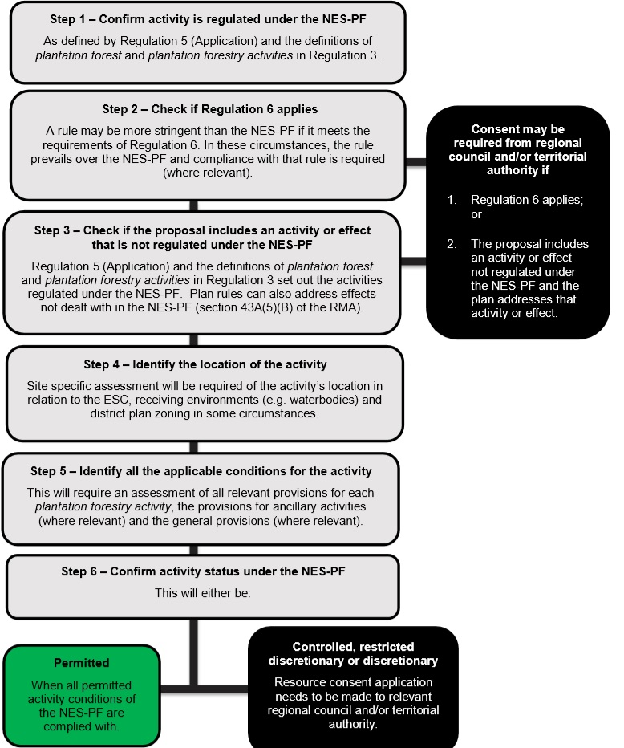

Afforestation (pg 40):

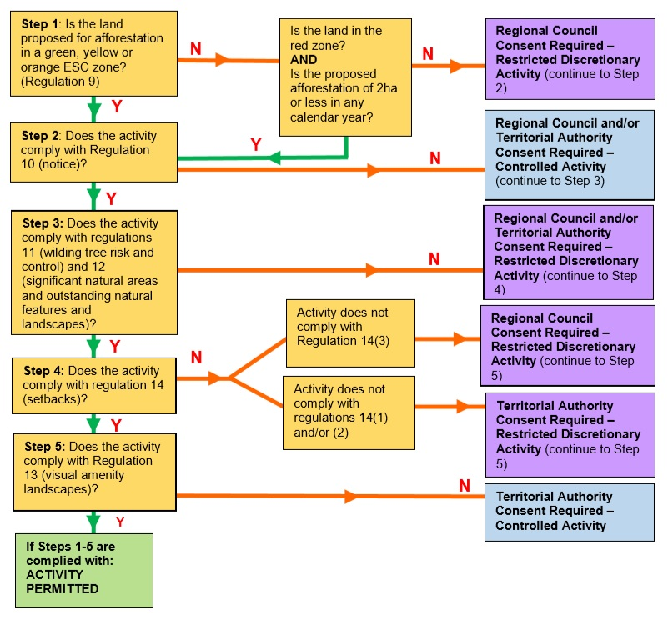

Pruning and thinning (pg 47):

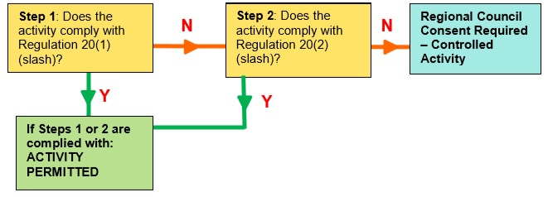
Harvesting (pg 89):

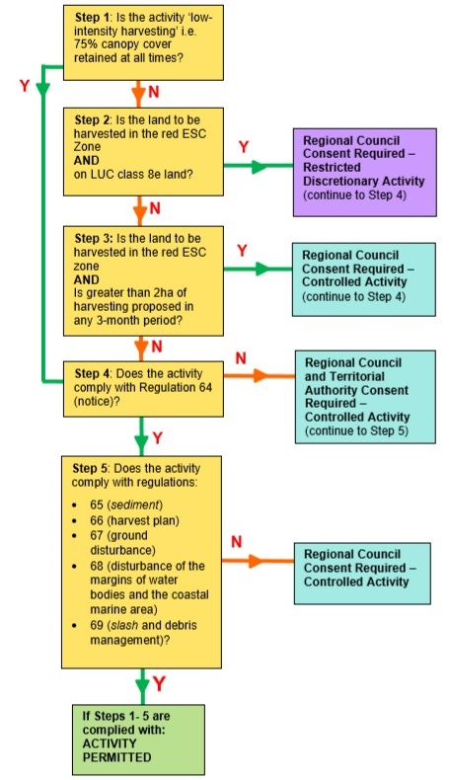

Replanting (pg 102):

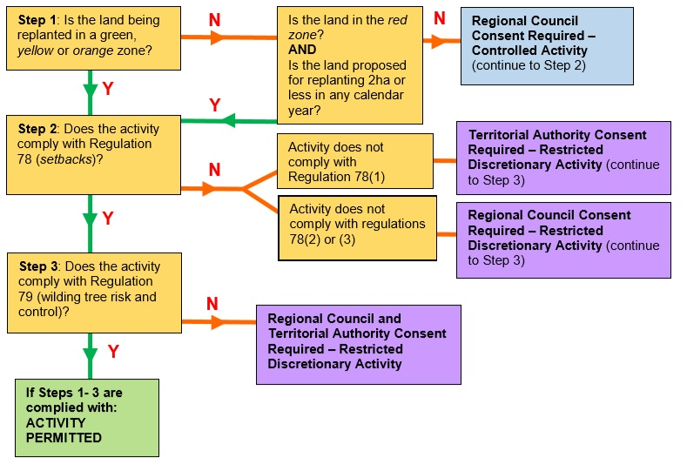

9. Best Practice Guidance:

The links below provide you with the relevant best practice information.

For scenarios 1 and 3 the most relevant information is the information that relates to:

Health and safety, waterway protection, riparian protection (or establishment) and maintenance, waterway crossing establishment and maintenance, earthworks, harvesting, sediment and erosion control, slash management and weed control post-harvest.

For scenarios 2 and 4 the most relevant information is the information that relates to:

Health and safety, safe tree felling, waterway and riparian protection, weed control, species selection and tree establishment.

https://www.nzffa.org.nz/farm-forestry-model/the-essentials/

https://worksafe.govt.nz/topic-and-industry/tree-work/safe-manual-tree-felling/

https://www.nzffa.org.nz/farm-forestry-model/resource-centre/information-leaflets/nzffa-guide-sheets-2007/

https://docs.nzfoa.org.nz/forest-practice-guides/

https://www.tanestrees.org.nz/files/planting-and-managing-native-trees-technical-handbook_oct_2018.pdf

Objectives should be SMART - Specific, Measurable, Acheiveble, Realistic, and Time bound – here is some supporting information for you to use if you like - https://managingwholes.com/good-goals.htm/

